KEYBOARD ACCELERATORS

Keyboard accelerators are key combinations that let users quickly run commands without using the mouse. They usually combine a modifier key (such as **Ctrl**, **Alt**, or **Shift**) with another key (like **A**, **B**, or **C**).

Purpose of Keyboard Accelerators

Keyboard accelerators are useful because they:

* **Increase efficiency**: Users can perform actions faster without switching between mouse and keyboard.
* **Reduce eye strain**: Less need to look back and forth between the screen and input devices.
* **Improve accessibility**: They help users who may have difficulty using a mouse by offering keyboard-based control.

Common Keyboard Accelerator Usage

Keyboard accelerators are widely used in various software applications, including:

* **Word Processors:**Copy (Ctrl+C), Paste (Ctrl+V), Undo (Ctrl+Z), Redo (Ctrl+Y)
* **Web Browsers:**   
  Open New Tab (Ctrl+T), Close Tab (Ctrl+W), Switch Tabs (Ctrl+Tab/Ctrl+Shift+Tab), Save Page (Ctrl+S)
* **Operating Systems:**Cut (Ctrl+X), Copy (Ctrl+C), Paste (Ctrl+V), Undo (Ctrl+Z), Redo (Ctrl+Y), Save (Ctrl+S), Print (Ctrl+P)

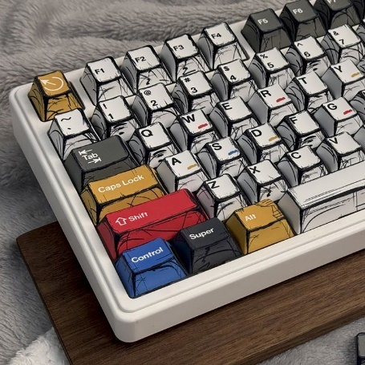

Implementing Keyboard Accelerators

Keyboard accelerators can be added to programs in several common ways:

* **Windows API**: Windows provides functions such as CreateAcceleratorTable and TranslateAccelerator to define and process keyboard shortcuts in native Windows applications.
* **Cross-platform toolkits**: Toolkits like **Qt** and **GTK+** include built-in support for keyboard accelerators, making it easier to use the same shortcuts across different operating systems.
* **Application frameworks**: Frameworks such as **.NET** and **Electron** offer higher-level tools to define and handle keyboard shortcuts without dealing directly with low-level system calls.

These options let developers choose the approach that best fits their platform and application needs.

Benefits of Keyboard Accelerators

**For users**

* Faster work and better efficiency
* Less eye strain (less switching between mouse and keyboard)
* Better accessibility for users who prefer or need keyboard input
* Higher overall productivity

**For developers**

* Cleaner menus with fewer items
* Simpler command access logic
* Better overall user experience

Encouraging Users to Use Keyboard Accelerators

Developers can help users adopt shortcuts by:

* **Showing shortcuts clearly** next to menu items or in a shortcut list
* **Providing documentation or help** that explains common shortcuts
* **Allowing customization** so users can change shortcuts to suit their needs

Guidelines for Assigning Keyboard Accelerators

When choosing keyboard shortcuts, keep these rules in mind:

* **Be consistent** with common programs so users don’t have to relearn shortcuts
* **Avoid system keys** like Tab, Enter, Esc, and Spacebar
* **Use modifier keys** (Ctrl, Alt, Shift) to avoid conflicts
* **Support old and new shortcuts** when users may expect both
* **Reserve F1 for Help**
* **Avoid F4, F5, and F6**, as they are commonly used by Windows and MDI applications

Following these guidelines helps create shortcuts that are easy to learn, safe to use, and consistent with Windows standards.

Examples of Recommended Keyboard Accelerators

Here's a table of common keyboard accelerators and their associated functions:

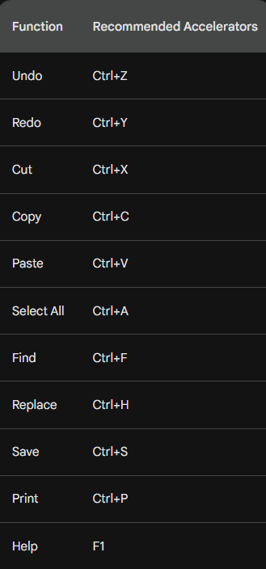

THE ACCELERATOR TABLE

An accelerator table is a data structure that defines keyboard shortcuts for menu items and other actions in a Windows application. Each entry in the table specifies an ID, a keystroke combination, and the corresponding menu item or action.

Defining Accelerators in Developer Studio

* You can define accelerator tables using the Accel Properties dialog box in Developer Studio. To create an accelerator table:
* Select the menu item or action for which you want to define a shortcut.
* Right-click and select "Properties" from the context menu.
* In the Properties dialog box, click the "Accel" button.
* In the Accel Properties dialog box, enter a keystroke combination in the "Keystroke" field. You can use virtual key codes, ASCII characters, or a combination of both in conjunction with the Shift, Ctrl, or Alt keys.
* Click "OK" to save the accelerator.
* Loading the Accelerator Table in Your Program.

To load an accelerator table into your program, you use the LoadAccelerators function. This function takes two parameters:

* hInstance: The handle to the program's instance.
* lpAcceleratorName: The name of the accelerator table resource. The resource name can be a string or a number.

Here's an example of how to load an accelerator table named MyAccelerators:



Once the accelerator table is loaded, you can use it to translate keystrokes into menu IDs or actions. The TranslateAccelerator function takes three parameters:

* hWindow: The handle to the window that receives the keystroke.
* hMsg: The handle to the message that contains the keystroke.
* wParam: The wParam value of the message.

The TranslateAccelerator function returns a menu ID if the keystroke matches an accelerator in the table. If the keystroke does not match an accelerator, it returns 0.

Here's an example of how to use the TranslateAccelerator function:



If menuID is not 0, it is the ID of the menu item that corresponds to the keystroke. You can then use this ID to perform the corresponding action.

Tips for Defining Accelerators

When defining accelerators, keep the following tips in mind:

* **Use consistent keystrokes** for similar actions. For example, you might use Ctrl+Z for undo and Ctrl+X for cut.
* **Avoid using keystrokes that are already used by Windows.** For example, you should not use Ctrl+C for copy, as this is already used by Windows.
* **Use descriptive keystrokes.** For example, you might use Ctrl+F for find and Ctrl+H for replace.

Loading the Accelerator Table

The LoadAccelerators function is used to load an accelerator table into memory and obtain a handle to it. The syntax of the LoadAccelerators function is as follows:

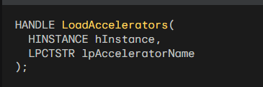

The hInstance parameter is the handle to the program's instance. The lpAcceleratorName parameter is the name of the accelerator table resource. The resource name can be a string or a number.

Here's an example of how to load an accelerator table named MyAccelerators:



Translating Keystrokes

The TranslateAccelerator function is used to translate a keystroke message into a menu ID or action. The syntax of the TranslateAccelerator function is as follows:

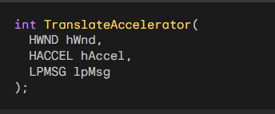

The hWnd parameter is the handle to the window that receives the keystroke. The hAccel parameter is the handle to the accelerator table. The lpMsg parameter is a pointer to the message structure that contains the keystroke.

The TranslateAccelerator function returns a menu ID if the keystroke matches an accelerator in the table. If the keystroke does not match an accelerator, it returns 0.

Here's an example of how to use the TranslateAccelerator function:

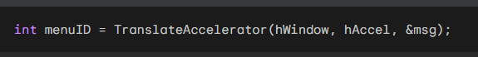

If menuID is not 0, it is the ID of the menu item that corresponds to the keystroke. You can then use this ID to perform the corresponding action.

Integrating Keyboard Accelerators into the Message Loop

To integrate keyboard accelerators into the message loop, you can modify the standard message loop as follows:

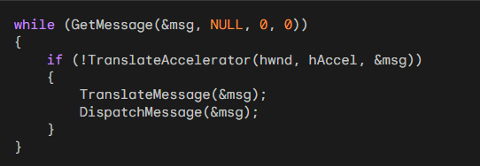

This code will first check whether the keystroke can be translated using the accelerator table.

If it can, the TranslateAccelerator function will send the corresponding message to the window procedure.

Otherwise, the code will continue with the normal message loop processing.

Understanding the hwnd Parameter

The hwnd parameter tells Windows **which window should receive the keyboard shortcut**.  
If you do not specify hwnd, the shortcut is sent to **whatever window currently has focus**.

Keyboard Accelerators and Modal Dialogs

Keyboard accelerators **do not work** when a modal dialog box or message box is active.  
This happens because dialog boxes and message boxes **do not use the normal message loop** of your program.

If you really need keyboard shortcuts to work inside a modal dialog or message box, you must use a different method.  
One option is to install a **keyboard hook** using SetWindowsHookEx, which allows your program to intercept key presses **before** they reach the dialog.

In practice, most programs **do not do this**, since keyboard shortcuts are usually disabled while modal dialogs are open.

Types of Accelerator Messages

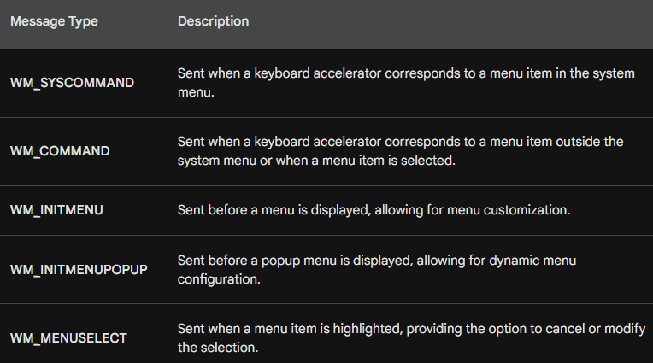

How TranslateAccelerator Works

TranslateAccelerator converts key presses into Windows messages.  
It sends **either WM_SYSCOMMAND or WM_COMMAND**, depending on what the shortcut is linked to.

System Menu Accelerators → WM_SYSCOMMAND

If a keyboard shortcut matches an item in the **system menu** (such as Restore, Move, or Close),  
Windows sends a **WM_SYSCOMMAND** message to the window procedure.

This means the command was triggered from the system menu using the keyboard.

Other Menu Accelerators → WM_COMMAND

If the shortcut matches a **normal menu item** (not part of the system menu),  
Windows sends a **WM_COMMAND** message instead.

WM_COMMAND Message Information

WM_COMMAND includes details about the command:

* LOWORD(wParam) → command or accelerator ID
* HIWORD(wParam) → notification code
* lParam → handle of the control (if applicable)

Extra Menu Messages

When an accelerator activates a menu item, Windows also sends:

* WM_INITMENU – before the menu opens
* WM_INITMENUPOPUP – before a popup menu opens
* WM_MENUSELECT – when a menu item is highlighted

These messages behave the same as if the menu was clicked with the mouse.

Disabled Menu Items

If a shortcut is linked to a **disabled or grayed** menu item,  
no message is sent. The command cannot be activated by the keyboard.

Accelerators and Minimized Windows

When a window is **minimized**, keyboard shortcuts that map to **enabled system menu items** still work. In this case, WM_SYSCOMMAND messages are sent.

Handling Non-System Menu Accelerators When a Window Is Minimized

If a keyboard accelerator **does not belong to the system menu**, TranslateAccelerator still works **even when the window is minimized**.

* Windows sends a **WM_COMMAND** message to the window procedure.
* This allows non-system commands to be triggered by keyboard shortcuts.
* Users can still use shortcuts for actions that are not part of the system menu.

**In short:**  
System menu shortcuts → WM_SYSCOMMAND  
Other shortcuts → WM_COMMAND (even if the window is minimized)

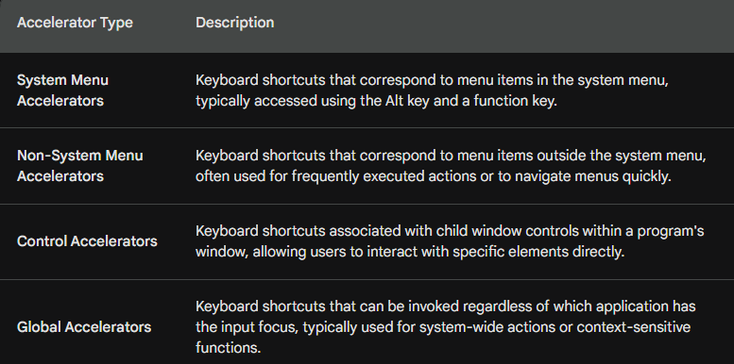

Additional Points:

* Accelerator IDs are unique identifiers assigned to each keyboard shortcut, allowing the window procedure to distinguish between different accelerators.
* Notification codes provide additional information about the type of command or action triggered by the accelerator.
* Child window handles identify the specific control associated with a control accelerator.
* Global accelerators are registered using the RegisterHotKey function and require elevated privileges in some cases.

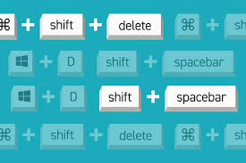

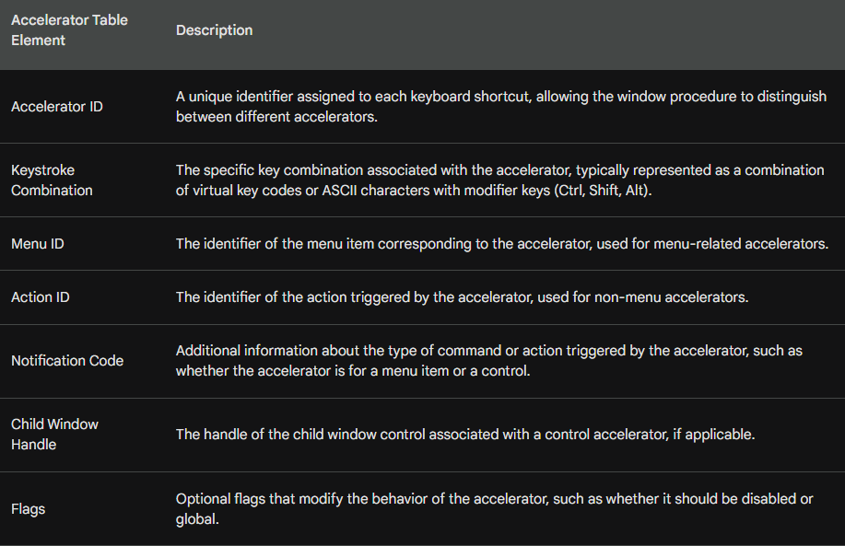

Basically, TranslateAccelerator handles your keyboard shortcuts. It turns your keypresses into commands the app understands, making it much faster to get things done.

*Popad2 program in chapter 10 folder….*

POPPAD2: A Rudimentary Notepad with Menus and Accelerators

POPPAD2 takes the foundation of our first version and makes it feel like a real application. Here’s what’s new:

* **Menus:** You now have File and Edit menus for quick access to "New," "Open," "Save," and more.
* **Shortcuts:** We’ve mapped menu items to keyboard shortcuts (accelerators) so you don't have to rely solely on the mouse.
* **Better Text Control:** Under the hood, we’re using an edit control to handle all the heavy lifting for editing, from "Select All" to "Undo."

FUNCTIONALITY BREAKDOWN

Menu & Resource Breakdown

**File Menu** For now, the File options (New, Open, Save, Print) are just placeholders; selecting them will simply trigger a beep. We’ll be implementing the actual logic for these in the coming chapters.

**Edit Menu** Most of these actions are handled by sending standard messages directly to the edit control:

* **Undo/Cut/Copy/Paste:** Sent via WM_UNDO, WM_CUT, WM_COPY, and WM_PASTE.
* **Clear:** Uses WM_CLEAR to wipe the selection.
* **Select All:** Uses EM_SETSEL to highlight everything at once.

The menu is also context-aware—options like "Cut" or "Copy" will automatically gray out if no text is selected.

**The Resource Files (.RC & RESOURCE.H)** To keep the code clean and readable, we use these two files to manage the app's "look and feel":

* **POPPAD2.RC:** This is our toolkit. It defines the icons, the layout of our File/Edit/Help menus, and the **Keyboard Accelerators** (like Ctrl+C for copy or F1 for help).
* **RESOURCE.H:** This maps numerical IDs to readable names (like IDM_EDIT_COPY). This way, we can refer to "Copy" in our code by name rather than a random number.

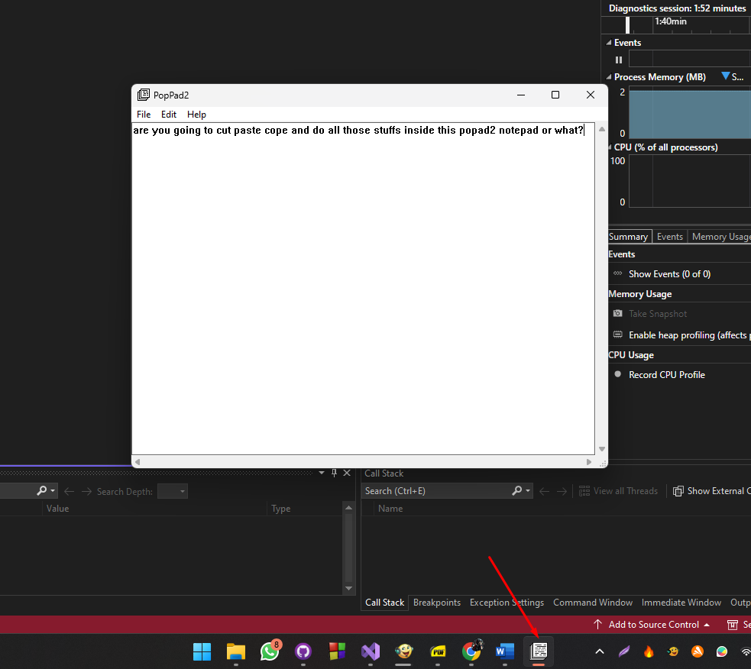

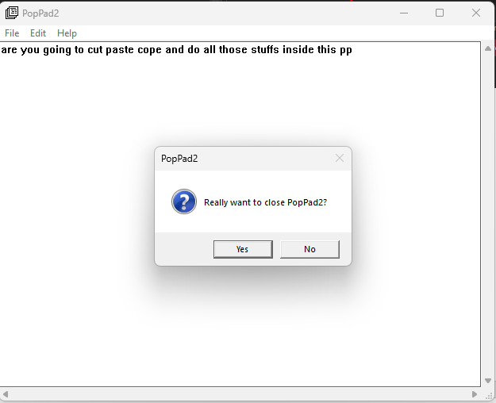 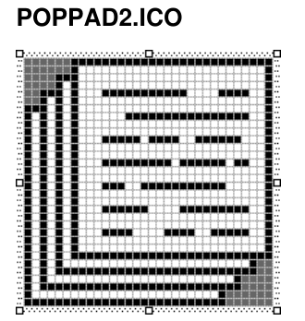

Deep Dive: Handling Menus and Accelerators

The POPPAD2.RC file isn't just a list; it’s where we tie the UI together. By using a tab (\t) in the menu strings, we display the shortcut keys right next to the command names, keeping the interface standard and clean.

I. Dynamic Menu Control (WM_INITMENUPOPUP)

Rather than keeping all menu items active at all times, POPPAD2 uses the WM_INITMENUPOPUP message to "audit" the menu before it even opens. This ensures the user only sees options that actually make sense in the moment:

* **Undo:** We query the edit control with EM_CANUNDO. If there’s nothing to undo, the option is grayed out.
* **Paste:** We check IsClipboardFormatAvailable. If there’s no text on the clipboard, "Paste" stays disabled.
* **Cut, Copy, & Delete:** We use EM_GETSEL to see if any text is highlighted. If the start and end positions are the same, it means nothing is selected, so these options are disabled.

II. Keyboard Accelerators

We’ve mapped standard Windows shortcuts (like Ctrl+Z, Ctrl+X, and Ctrl+V) to their respective IDs. This allows the application to catch these keystrokes and treat them exactly like a menu click, keeping our command logic centralized.

COMMAND PROCESSING: HOW IT WORKS

Because we are using a standard **edit control** (hwndEdit), handling the Edit menu is incredibly straightforward. Instead of writing complex text-manipulation logic, we simply forward the command to the control.

1. The Edit Menu

For most editing tasks, we just "pass the buck" to the edit control using SendMessage.

* **Undo, Cut, Copy, Paste, and Clear:** Each of these sends a single message—like WM_UNDO or WM_PASTE—directly to the edit control.
* **Select All:** Since there isn't a single "select all" message, we use SendMessage(hwndEdit, EM_SETSEL, 0, -1); to highlight everything from the first character to the last.

2. The Help Menu (About Box)

The "About" option simply triggers a standard Windows message box to display the app name and copyright info:



3. Graceful Exits & Confirmation

We want to make sure users don't lose their work by accident. To handle this, we split the exit logic into two steps:

**The Trigger:** When a user clicks "Exit" in the menu, we don't kill the app immediately. Instead, we send a WM_CLOSE message.

**The Confirmation:** Inside the WM_CLOSE handler, we call a custom function, AskConfirmation. This pops up a "Are you sure?" dialog.

* If the user clicks **Yes**, we call DestroyWindow().
* If they click **No**, we ignore the request and the app stays open.



4. Handling Shutdowns and Confirmations

To keep things consistent, we use a single helper function, AskConfirmation, whenever the app is about to close. This ensures the user always gets a "Are you sure?" prompt.

**The Confirmation Helper**

This simple function pops up a standard "Yes/No" dialog. It returns IDYES if the user confirms and IDNO if they change their mind.



5. Dealing with Windows Shutdown (WM_QUERYENDSESSION)

What happens if the user tries to shut down Windows while the app is open? Windows sends a WM_QUERYENDSESSION message to every open window to ask, "Is it okay to close you?"

* **If the user clicks "Yes"** in our prompt: We return 1 (True), telling Windows it’s safe to proceed with the shutdown.
* **If the user clicks "No"**: We return 0 (False). This actually stops the entire Windows shutdown process, giving the user a chance to save their work.

6. Final Notification (WM_ENDSESSION)

After the query, Windows sends WM_ENDSESSION. This is just a courtesy message that tells the app the final verdict: "Yes, we are definitely shutting down now" or "No, the shutdown was canceled."

MODAL VS. MODELESS: WHAT’S THE DIFFERENCE?

Think of a **Modal Dialog** like a "stop sign." When it pops up, you *must* deal with it (click OK or Cancel) before you can touch the main window again. This is what most "About" or "Settings" boxes are.

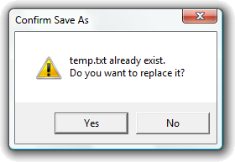

A **Modeless Dialog** is more like a "sticky note." It stays open, but you can still click back and forth between it and the main window (like the "Find and Replace" box in Word).

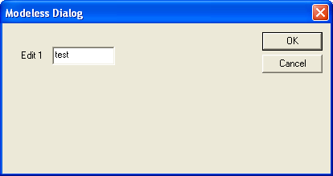

How the "ABOUT1" Program Works

To create a dialog box, the program uses three main parts:

1. The Resource File (.RC)

This is where you "draw" the dialog. Instead of writing code for every button, you define it in the resource file:

* **Styles:** DS_MODALFRAME tells Windows it’s a modal box; WS_POPUP gives it that classic pop-up look.
* **Controls:** You list the static text (labels), the icon, and the "OK" button.
* **Menu:** Defines the "Help" menu so the user has something to click to open the box.

2. The Main Code (WinMain & WndProc)

This part runs the main window. When you click "About" in the menu:

* WndProc catches the WM_COMMAND message.
* It calls the DialogBox() function.
* **Crucial Note:** Once DialogBox() is called, the main window "freezes" (goes modal) until the dialog is closed.

3. The Dialog Procedure (AboutDlgProc)

Just like your main window has a WndProc, your dialog has its own "brain."

* **WM_INITDIALOG:** This is where you set things up right before the box appears.
* **WM_COMMAND:** This waits for the user to click the "OK" button. When they do, the function calls EndDialog(), which kills the box and hands control back to the main window.

Designing The "About" Box Visually

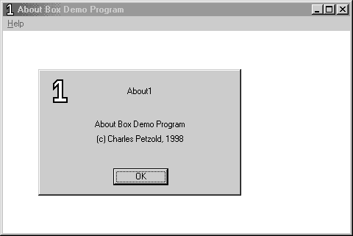

Instead of typing out coordinates in a text file, you can "draw" your dialog box using the Resource Editor. Here is the workflow for setting up the ABOUT1 box:

1. Creating the Canvas

* **Start the Dialog:** Go to the **Insert** menu → **Resource** → **Dialog**. You'll get a blank box with "OK" and "Cancel" buttons by default.
* **Set the Identity:** Right-click the box, hit **Properties**, and change the ID to AboutBox. This is the name your C/C++ code will use to find it.
* **Positioning:** Set the X and Y positions to 32. This ensures the box pops up in a consistent spot relative to your main window.

2. Refining the Style

* **Remove the Title Bar:** In the **Styles** tab, uncheck "Title Bar." This gives the box a cleaner, simpler look.
* **Clean up Buttons:** Since an "About" box only needs one way out, click the **Cancel** button and hit **Delete**. Move the **OK** button to the bottom-center.

3. Adding Content (Controls)

Use the **Controls Toolbar** to drag and drop elements onto your dialog:

* **The Icon:** 1. Pick the **Picture** tool and drag a square on the box. 2. In Properties, change the Type to **Icon** and set the ID to IDC_STATIC. 3. Select your icon name (About1) from the list.
* **The Text:** 1. Use the **Static Text** tool to place three labels. 2. In the **Caption** field, type your program name, version, and copyright info. 3. Set the alignment to **Center** in the Styles tab to keep it looking professional.

4. Fine-Tuning

* **Sizing:** You can drag the edges of the dialog to resize it.
* **Pixel-Perfect Accuracy:** Check the bottom-right corner of the screen; it shows the exact coordinates and size of whatever you are currently moving.
* *Tip:* Hold **Shift + Arrow Keys** to resize a control by a single pixel at a time.

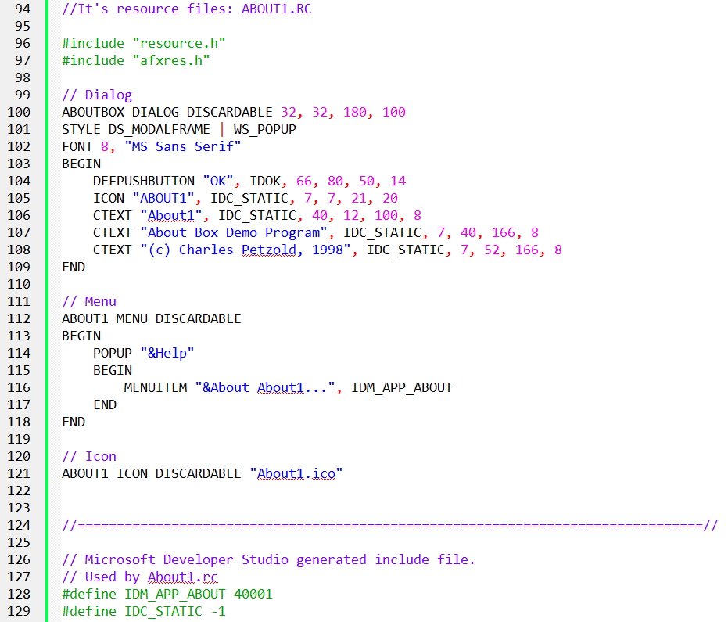

The Dialog Template: How Windows "Draws" the Box

When you see a line like ABOUTBOX DIALOG DISCARDABLE 32, 32, 180, 100 in the resource script, here is what actually matters:

1. "Dialog Units" vs. Pixels

The most important thing to remember is that **coordinates are not in pixels.** Windows uses "Dialog Units" based on the size of the system font.1

* **The Reason:** This ensures your dialog box doesn't look tiny on a high-resolution 4K monitor or huge on a low-res one. It scales automatically so the text always fits inside the buttons.
* **The Math (Optional):** X-units are $1/4$ of a character's width; Y-units are $1/8$ of a character's height.

2. The Style Flags

**WS_POPUP & DS_MODALFRAME:** These are the standard "ingredients" for a dialog.2 They tell Windows to remove the standard window borders and make it a solid, pop-up modal box.

3. Defining the "Innards" (BEGIN and END)

Everything between BEGIN and END is just a list of child controls. You only need to know three types for this program:

* **DEFPUSHBUTTON:** The "Default" button (usually OK).3 It’s the one that triggers if the user hits the Enter key.
* **ICON:** Just a placeholder that pulls the image from your resource file.
* **CTEXT:** "Centered Text." It’s a static label that automatically centers your text within the box you define.

The Building Blocks of the Dialog

In a resource script, you use "keywords" that are actually shortcuts for complex window settings.

1. The Three Main Controls

* **CTEXT (Centered Text):** This is just a "Static" window. It automatically combines the styles for being a child window, being visible, and centering the text.
* **ICON:** You don't need to set a size for this. Windows looks at your icon file and automatically makes the control the right size to fit the image.
* **DEFPUSHBUTTON:** This is the "Default" button. If the user hits **Enter**, Windows automatically "clicks" this button for them.

2. Understanding IDs

Every item in your dialog needs an ID so the program knows what is being clicked:

* **IDOK:** This is a built-in Windows ID (set to 1). It’s standard for the "OK" button.
* **IDC_STATIC:** This is set to **-1**. Because we never need to change the "About" text or the icon while the program is running, we give them this "dummy" ID. It tells Windows: "I'll never need to talk to this control again."

3. New Styles: Grouping and Tabbing

You'll see WS_GROUP and WS_TABSTOP in the code.

* **WS_TABSTOP:** Allows the user to move to this control using the **Tab** key.
* **WS_GROUP:** Helps group buttons together (like radio buttons).
* *Note: These aren't very important for a simple "About" box with only one button, but they become vital when you have complex forms.*

The Secret Language of Dialog Controls

In a normal window, you have to write long lines of code to create a button. In a **Dialog Template**, Windows gives you "shorthand" nicknames that do the heavy lifting for you.

1. The "Nickname" Identifiers

Instead of typing out CreateWindow with ten different parameters, you use these shortcuts:

* **CTEXT**: This is shorthand for a **Static Text** window that is already visible, centered, and attached as a child.
* **ICON**: You just give it a name, and Windows handles the rest. You don't even need to set a size; it just uses the dimensions of the icon file.
* **DEFPUSHBUTTON**: This is the "Main" button. It’s special because it reacts when the user hits the **Enter** key.

2. Understanding IDs (The Phone Numbers)

Every control needs an ID so the code knows who is talking.

* **IDOK (Value: 1)**: This is a built-in "VIP" ID. Windows already knows that this usually means "Close the box and save changes."
* **IDC_STATIC (Value: -1)**: This is the "Do Not Disturb" ID. Since we never need to change the "About" text while the app is running, we give it an ID of -1. This tells Windows, "I'm never going to send this control a message, so don't bother tracking it."

3. New Layout Rules

* **The Grid**: As we mentioned, everything is measured in **Dialog Units** (fractions of a character's size) so it looks right on any screen.
* **The "Group" Style**: You’ll see WS_GROUP and WS_TABSTOP. Think of these as "Navigation" markers. They tell Windows how to move the focus when the user presses the **Tab** key or the **Arrow** keys.

Understanding the ABOUT1 Dialog Box Procedure

This section delves into the code and functionality of the AboutDlgProc function, which handles messages for the ABOUT1 dialog box:

I. Function Definition:



Parameters:

* hDlg: Handle to the dialog box window.
* message: Message sent to the dialog box.
* wParam: Additional message-specific information.
* lParam: Additional message-specific information.

Return Type:

* BOOL: TRUE if the message is processed, FALSE otherwise.

Differences from a Window Procedure:

* Return Type: Dialog box procedures return BOOL (treated as int), while window procedures return LRESULT.
* Message Processing: Dialog box procedures return TRUE when handling a message and FALSE otherwise, unlike window procedures that require calling DefWindowProc if they don't handle the message.
* Messages Handled: Dialog box procedures don't handle WM_PAINT, WM_DESTROY, or receive WM_CREATE. They specifically handle WM_INITDIALOG for initialization and WM_COMMAND for user interactions.

The Dialog Procedure: How it Thinks

The AboutDlgProc is a callback function that handles messages specifically for the dialog. Here’s how it manages the conversation:

I. The Startup: WM_INITDIALOG

This is the very first message the dialog gets. It’s your chance to do any last-minute setup before the user sees the box.

* **The Focus Rule:** If you return TRUE, Windows automatically puts the "focus" (the blue highlight) on the first available button.
* **Manual Mode:** If you want the focus to start on a specific text box or a different button, you call SetFocus yourself and return FALSE.

II. The Interaction: WM_COMMAND

When the user interacts with the dialog—like clicking the "OK" button or hitting the Spacebar—Windows sends a WM_COMMAND.

* **Checking the ID:** The program looks at the message to see the ID. If it sees IDOK, it knows the user is done.
* **The Exit:** To close the box, you don't use DestroyWindow. Instead, you call EndDialog(hDlg, 1);. This kills the dialog and sends a "success" signal back to the main program.

III. Handling Everything Else

In a normal WndProc, you pass unhandled messages to DefWindowProc. **Don't do that here!**

* If you handled the message: Return TRUE.
* If you didn't handle it: Return FALSE. This tells Windows, "I'm not interested in this message; you handle it for me."

Why Keyboard Shortcuts Don't Work

You might notice your main app's shortcuts (like Ctrl+S) stop working while the "About" box is open.

**The Reason:** Modal dialog boxes have their own private "mini-message loop" inside Windows.

They don't check your main program's message queue, so they never "see" your keyboard accelerators. The dialog is strictly focused on its own buttons and controls.

How the "About" Box is Launched

Launching a dialog box is a bit like calling a specialized subcontractor to handle a specific task while the main boss (your main window) takes a break.

I. Getting the "Key" (The Instance Handle)

When your program first starts (WM_CREATE), it grabs its "Instance Handle" (hInstance). Think of this as the program's ID badge. You need this badge later to prove to Windows that you have the right to open the resources (like the dialog) stored in your file.

II. Waiting for the Click

Your main window keeps an eye out for a WM_COMMAND message. If it sees the ID IDM_APP_ABOUT, it knows the user just clicked "About" in the menu.

III. Calling the DialogBox Function

This is the moment of truth. The program calls the DialogBox function, which needs four things:

* **The ID Badge:** Your hInstance.
* **The Blueprint:** The name of the dialog in your resource file ("AboutBox").
* **The Parent:** Your main window handle (hwnd).
* **The Brain:** The name of the function that will handle the dialog's logic (AboutDlgProc).

IV. The "Pause" Button

One of the most important things to understand is that **DialogBox is a blocking call.** * When you call it, your main WndProc stops right there and waits.

* The "About" box takes over.
* The DialogBox function won't finish (or "return") until the user clicks OK and EndDialog is called.

V. How Users Close It

Users have three ways to trigger that "OK" button:

1. **Click it** with the mouse.
2. **Hit Spacebar** (if the button is highlighted).
3. **Hit Enter** (because we labeled it a "Default" button).

*Pro Tip:* Even though we didn't add a Cancel button, hitting **Escape** usually sends an IDCANCEL message automatically.

VI. Talking Back to the Parent

Even though the main window is "paused," it’s not dead. The dialog box is a "child" of the main window. If the dialog needs to tell the main window something, it can send a message "home" using: SendMessage(GetParent(hDlg), ...);

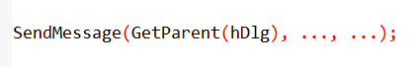

Customizing Your Dialog Boxes

While the visual editor is great, knowing how the resource script works allows you to tweak the "look and feel" of your windows in ways a drag-and-drop tool might miss.

I. Changing the Window Style

Our "About" box was very simple, but you can add standard window features by mixing and matching styles:

* **WS_CAPTION**: Adds a title bar at the top. This makes the window draggable so the user can move it out of the way.
* **WS_SYSMENU**: Adds that little icon in the top-left (or the 'X' in the top-right) so users can close or move the box using the system menu.
* **WS_THICKFRAME**: This makes the dialog box resizable. Usually, you don't want this for an "About" box, but it’s useful for complex tools.

II. Advanced Visual Tweaks

* **Custom Fonts**: You aren't stuck with the default system font. By using the FONT statement in your script, you can give your dialog a unique look (just make sure the user has that font installed!).
* **Adding Menus**: It’s rare, but you *can* actually put a menu bar (File, Edit, etc.) inside a dialog box just like a main window.
* **Custom Classes**: If you want your dialog to behave in a very specific, non-standard way, you can give it its own "Window Class." This is an advanced move we'll see later in the HEXCALC project.

III. Why Bother with Manual Scripting?

Even though Visual Studio has a visual editor, sometimes you need to "hand-code" the resource script.

* **Precision**: Sometimes it's faster to type a coordinate than to nudge a box with a mouse.
* **Complex Layouts**: For math-heavy apps like calculators, where every button needs to be perfectly aligned in a grid, writing the script manually (or using a loop to generate it) is much more efficient.

IV. Key Takeaway

A dialog box is just a window with special "pre-set" behaviors. By changing the styles in the resource script, you can make a dialog look exactly like a main application window or something entirely unique.

How Windows "Builds" Your Dialog

When you call DialogBox, you aren't just opening a window; you're handing Windows a "blueprint" (the template) and asking it to do the heavy lifting.

I. The Construction Process

Think of DialogBox as a high-level wrapper for CreateWindow. Here’s what Windows does once you call it:

* **Reads the Blueprint:** It pulls the coordinates, size, and style from your resource script.
* **Registers the Class:** Windows uses a special, built-in "Dialog Class" to make sure the window behaves like a dialog (handling things like the Tab key automatically).
* **Starts the Conversation:** It uses the address of your AboutDlgProc to send messages back and forth.

If you didn't use DialogBox, you would have to manually call CreateWindow for the main box and every single button or text label inside it—which is a massive headache!

II. Creating Dialogs "On the Fly" (DialogBoxIndirect)

Normally, you define your dialogs ahead of time in a resource file (.RC). But what if your program doesn't know what the dialog should look like until it's actually running?

* **DialogBoxIndirect** lets you build a dialog template in memory while the program is active.
* Instead of reading from a file, it reads from a data structure you created in your code. This is perfect for complex apps that need to generate custom menus or forms dynamically.

III. Shorthand for Child Controls

As we've seen, keywords like CTEXT or DEFPUSHBUTTON are just "shortcut" names. They tell Windows exactly which **Window Class** and **Style** to use without you having to type out long strings of code.

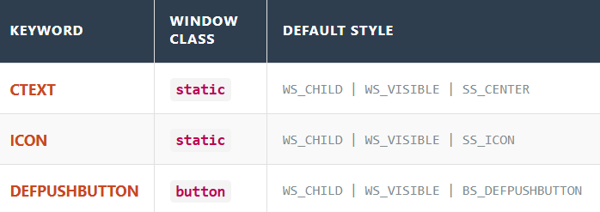

**NB:** The whole point of the Dialog system is **automation**. Windows takes your simple list of controls and handles the messy work of registering classes and creating multiple child windows so you can focus on the logic.

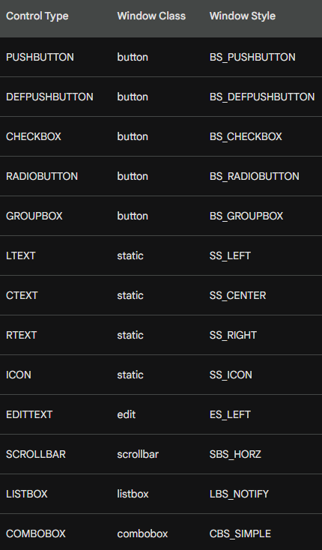

The Resource Compiler’s Cheat Sheet

Think of the Resource Compiler as a translator. It takes these shorthand lines and converts them into the complex CreateWindow calls that Windows actually understands.

**1. Two Main Formats** Most controls follow a simple "label first" pattern, but a few skip the text:

* **With Text:** control-type "Label", id, x, y, width, height, style *(Used for: Buttons, Icons, Static Text)*
* **Without Text:** control-type id, x, y, width, height, style *(Used for: Edit fields, Listboxes, Scrollbars, Comboboxes—where the user provides the content later)*

**2. Built-in Defaults** You don't have to tell Windows that a control is a child or that it should be seen. Every control in a dialog has these two "invisible" styles by default:

* WS_CHILD
* WS_VISIBLE

**3. The Optional Style Flag** The very last parameter (iStyle) is optional. You only add it if you want to give the control "extra powers," like making an edit box read-only or adding a border.

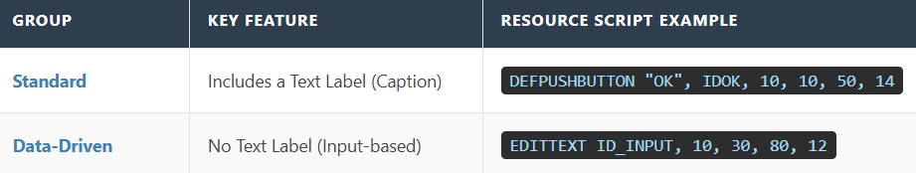

Fine-Tuning Your Controls

Think of the standard controls (like EDITTEXT) as "presets." Most of the time they work fine, but sometimes you need to go off-script.

I. The "Math" Reminder

Just a heads-up: Windows still uses those **Dialog Units** (1/4 character width, 1/8 character height) for every control you place. This keeps everything perfectly aligned, even if the user changes their screen resolution.

II. Using the "NOT" Trick

Usually, we add styles using the OR operator (|). But sometimes, you want to **remove** a feature that Windows includes by default.

**Example:** Most text boxes (EDITTEXT) come with a border. If you want a flat look, you use NOT WS_BORDER. This tells Windows: "Give me a text box, but take away the outline."

III. The "Power User" Statement: CONTROL

What if you want to use a control that doesn't have a shorthand nickname? Or what if you've invented your own custom UI element? You use the **CONTROL** statement.

It’s the most flexible way to build things because it doesn't make any assumptions. You have to tell it exactly what the "Class" is:

CONTROL "Submit", ID_SUB, "button", BS_PUSHBUTTON | WS_TABSTOP, 10, 10, 50, 14

How the "Dialog Manager" Works

When you launch a dialog, a background process called the **Dialog Manager** takes over. It acts like an automated construction foreman:

1. **The Shell:** It creates the empty popup window first.
2. **The Parts:** It loops through every CONTROL or CTEXT line in your script.
3. **The Build:** It calls CreateWindow for every single one of them, automatically converting your "Dialog Units" into real screen pixels.
4. **The Result:** You get a fully formed window with all its buttons and labels ready to go.

This next section shows you that there are two ways to write the exact same thing in your resource file. Think of it like a "Manual" way and a "Shortcut" way.

Two Ways to Build a Button

In your resource script, you can define an "OK" button using either of these lines. They result in the **exact same button** on your screen:

I. The "Manual" Way (CONTROL)

This is the detailed version. You have to list everything manually:

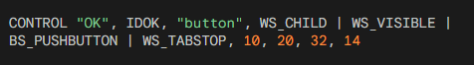

**Why use it?** It’s highly flexible. You can use it to create *any* type of window (like a custom graph or a special list) just by changing the class name ("button") or adding unique styles.

II. The "Shortcut" Way (PUSHBUTTON)

This is the simplified version. It’s much cleaner to read:



**Why use it?** It’s faster. When Windows sees PUSHBUTTON, it already knows you want the "button" class and the standard styles like WS_CHILD and WS_VISIBLE. You don't have to type them out every time.

Regardless of which way you write it, the parameters always follow this logic:

* **Label ("OK"):** What the user reads on the button.
* **ID (IDOK):** The "name" your C++ code uses to identify this button.
* **Location (10, 20):** The X and Y coordinates (starting from the top-left of the dialog).
* **Size (32, 14):** The width and height of the button.
* **Styles:** Extra rules, like WS_TABSTOP, which lets the user "land" on the button using the **Tab** key.

Think of the CONTROL statement as the "Pro Mode" for building dialog boxes. While shortcuts like PUSHBUTTON are great for standard stuff, CONTROL gives you total power over the details.

III. Why the CONTROL Statement is a Big Deal

Even though it’s more typing, the CONTROL statement is important for two main reasons:

1. It can create anything

With a shortcut like PUSHBUTTON, you are stuck making buttons. With CONTROL, you just change the "class" name to create whatever you want. You could put a scroll bar, a text entry box, or even a custom-made graph inside your dialog just by changing one word.

2. Total Style Control

Shortcuts give you the "standard" look. CONTROL lets you hand-pick every single behavior (style flag) the window has. If you want a button that behaves in a weird or specific way, this is how you build it.

IV. What’s Happening Behind the Scenes?

When you use the CONTROL statement, Windows does some of the work for you:

* **Automatic Settings:** You don't have to worry about telling Windows the control is a "child" or that it should be "visible." Even if you forget to type it, Windows automatically adds WS_CHILD and WS_VISIBLE for you.
* **The Translation:** When your program runs, Windows looks at that CONTROL line and translates it into a standard CreateWindow call. It calculates the exact pixel size based on the font you're using and places the control exactly where you asked.

What’s New in ABOUT2?

While ABOUT1 just showed a static box, **ABOUT2** is interactive. It lets the user pick colors and shapes that actually change the main window.

I. The Main Window (WndProc)

It does the usual stuff, but it adds a **WM_PAINT** handler. It uses two global variables—iColor and iFigure—to decide what to draw on the screen. When you change settings in the Dialog, this window redraws itself.

II. The Dialog Box (AboutDlgProc)

This is the "Control Panel." It has two main jobs:

* **Radio Buttons:** It uses CheckRadioButton to make sure only one option (like "Red") is picked at a time.
* **The "Preview" Window:** There is a small area inside the dialog box that shows you what your choice will look like before you hit OK.

III. Key Functions to Know

* **CheckRadioButton**: Automatically deselects the old choice when you click a new one.
* **GetDlgItem**: Helps the code find a specific button or text label inside the dialog by its ID.
* **InvalidateRect**: Tells a window (either the main one or the preview box) that it needs to redraw because the user changed a color or shape.

IV. The Resource Files (.RC and .H)

Think of these as the "Skin" and the "ID Cards":

* **ABOUT2.RC**: The blueprint. It uses GROUPBOX to draw boxes around the radio buttons and LTEXT as a placeholder for the preview area.
* **RESOURCE.H**: A list of IDs. IDC_ are for controls (buttons/circles) and IDM_ is for the menu.
* **ABOUT2.ICO**: The actual image file for the icon.



V. Summary of the Workflow

1. User clicks **Help → About**.
2. The Dialog pops up. User clicks a **Radio Button** for "Blue."
3. The Dialog's "Preview" area immediately turns blue.
4. User clicks **OK**. The Dialog closes and tells the main window to turn blue too.
5. If the user clicks **Cancel**, nothing changes.

Designing the ABOUT2 Dialog

When moving from a simple "About" box to one with choices (Radio Buttons), there are three things that matter in the Resource Editor:

I. The ID Sequence (The "Order" Rule)

When you create Radio Buttons (Black, Red, Green, etc.), create them **in order**.

* **Why?** It gives them sequential ID numbers (e.g., 101, 102, 103).
* **The Benefit:** This allows you to use a single line of code to handle the whole group instead of writing a separate "if" statement for every single button.

II. Using the "Group" Property

In the Resource Editor, you check the "Group" box for the **first** button in a set (like "Black" for colors and "Rectangle" for shapes).

* **How it works:** This tells Windows, "Start a new group here." All buttons following it will belong to that group until Windows hits another control with the "Group" property turned on.
* This ensures that clicking "Red" doesn't accidentally uncheck "Rectangle."

III. Tab Order

The order in which you click or create controls defines the **Tab Order**.

* This is simply the path the "focus" takes when a user presses the **Tab** key.
* *Pro Tip:* In the editor, you can usually press **Ctrl+D** to see the numbers and click them in the order you want the user to navigate.

IV. Summary for the Code

* **Sequential IDs** = Easier code logic.
* **"Group" Flag** = Keeps color choices separate from shape choices.
* **Tab Order** = Makes the dialog usable without a mouse.

How Buttons Talk to the Dialog Box

When you click a radio button, it doesn’t just change itself—it tells the Dialog Box what happened. This happens through a **notification message**.

I. The Message: WM_COMMAND

Think of WM_COMMAND as a status report sent to the Dialog Box every time a button is clicked. It contains:

* **Who:** The ID of the button (e.g., IDC_RED)
* **What:** The action code (usually BN_CLICKED)
* **Where:** The handle (the unique memory address of that button)

II. The Reaction: Handling the Click

Once the Dialog Box gets the message, it updates the UI. For example, if you click "Red," the code must:

* Put a dot in the Red button
* Remove the dots from Blue, Green, etc.

III. The Problem: How do I control buttons I didn’t click?

When you click "Red," the message only gives you the handle for Red. But your code also needs to **uncheck the other buttons**.

IV. The Solution: Two Easy Functions

**Step A: Find the button** (GetDlgItem)  
Since you only know the button’s ID (e.g., IDC_BLUE), ask Windows for its handle:

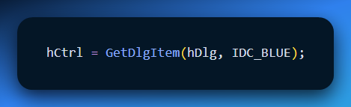

**Step B: Send an order** (SendMessage)  
Now that you have the handle, tell it to check or uncheck using BM_SETCHECK:

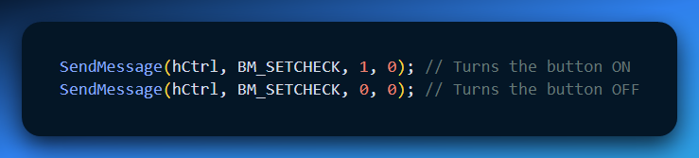

* 1 = Check it
* 0 = Uncheck it

V. The "Manual" Loop: How it works

If you were to write the logic yourself (the long way), you would use a loop to "talk" to every button in the group. The Logic:

1. **Catch the Click:** When you click a color, LOWORD(wParam) tells the program which ID was picked.
2. **The Loop:** The program cycles through every ID from IDC_BLACK to IDC_WHITE.
3. **The Decision:** If the ID in the loop **matches** the one you clicked, the program sends a 1 (Check it). If it **doesn't match**, it sends a 0 (Uncheck it).

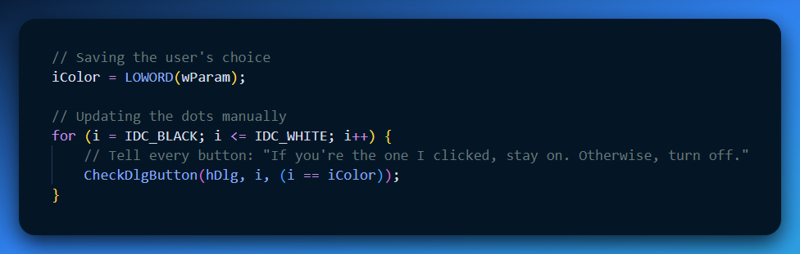

The Ultimate Shortcut: CheckRadioButton 💡

In a real Windows program, nobody writes that loop! Windows provides a built-in "Easy Button" called CheckRadioButton. It does the searching, the handles, and the checking for you in **one line**.

**The Shortcut Command:** CheckRadioButton(hDlg, IDC_BLACK, IDC_WHITE, iColor);

What this one line does:

* **hDlg**: Looks at your dialog box.
* **IDC_BLACK**: Starts at the first button in the group.
* **IDC_WHITE**: Stops at the last button in the group.
* **iColor**: Puts the dot in the one you actually clicked and automatically clears all the others.

**Why this matters**

* **Sequential IDs:** This is why we created the IDs in order (Black, Red, Green...). The function just counts from the "Start ID" to the "End ID."
* **Clean Code:** You replace a 10-line loop with a single, readable command.

Dialog Box Shortcuts for Radio Buttons and Check Boxes

This section discusses shortcuts available in Windows for handling radio buttons and check boxes in dialog boxes.

1. SendDlgItemMessage:

This function provides a shortcut to send messages directly to child controls within a dialog box. It takes five arguments:

* hDlg: The window handle of the dialog box.
* id: The ID of the child control.
* iMsg: The message identifier to send.
* wParam: Additional message-specific parameter.
* lParam: Additional message-specific parameter.

This function is equivalent to:



2. CheckRadioButton:

This function simplifies checking and unchecking radio buttons within a specific range. It takes four arguments:

* hDlg: The window handle of the dialog box.
* idFirst: The ID of the first radio button in the range.
* idLast: The ID of the last radio button in the range.
* idCheck: The ID of the radio button to check.

This function unchecks all radio buttons in the specified range except for the one with the idCheck value, which will be checked.

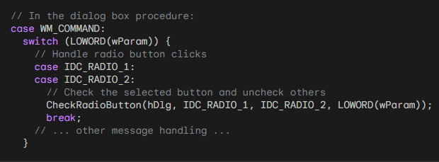

3. CheckDlgButton:

This function controls the check mark of a check box within a dialog box. It takes three arguments:

* hDlg: The window handle of the dialog box.
* idCheckbox: The ID of the check box.
* iCheck: Whether to check (1) or uncheck (0) the box.

Setting iCheck to 1 checks the box, while setting it to 0 unchecks it.

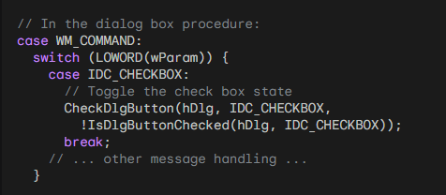

4. IsDlgButtonChecked:

This function retrieves the current check state of a check box within a dialog box. It takes two arguments:

* hDlg: The window handle of the dialog box.
* idCheckbox: The ID of the check box.

The function returns 1 if the checkbox is checked, and 0 if it is unchecked.

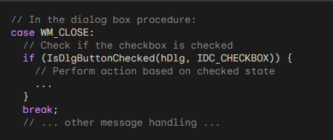

Using CheckDlgButton with BS_AUTOCHECKBOX:

If you define a checkbox with the BS_AUTOCHECKBOX style, you don't need to process the WM_COMMAND message. You can simply use IsDlgButtonChecked to retrieve the current state of the checkbox before closing the dialog box.

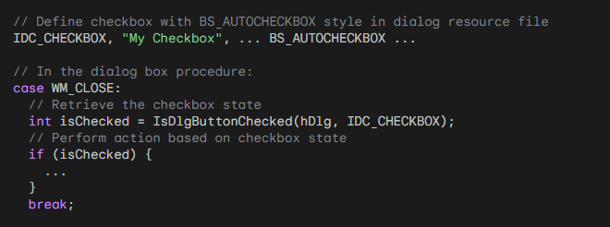

Using BS_AUTORADIOBUTTON:

With the BS_AUTORADIOBUTTON style, using IsDlgButtonChecked is inefficient because you would need to call it for each button until it returns true. Instead, you should still trap WM_COMMAND messages to track the selected button.

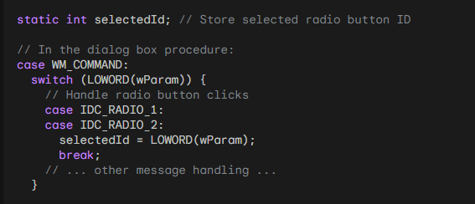

Remember to replace IDC_ constants with your actual control IDs.

Dialog Control & Termination (IDOK / IDCANCEL)

1. Default Logic & Keyboard Mapping

Windows handles specific IDs automatically within the dialog manager to facilitate standard UX.

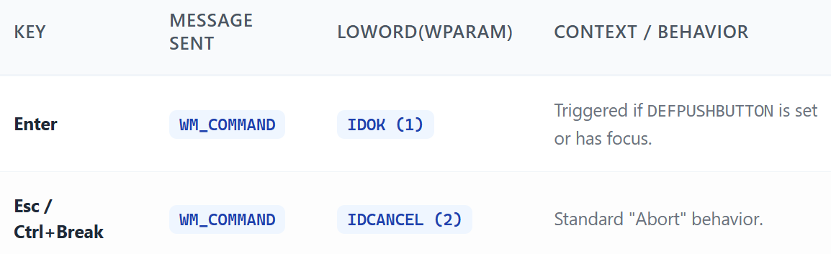

**Note:** If focus is on a different button, **Enter** triggers that button's ID instead of IDOK.

2. Message Handling Flow

Don't describe the switch; define the logic inside it.

**IDOK**:

* **Persist State**: Commit local dialog changes to global/static variables.
* **EndDialog(hDlg, TRUE)**: Destroy dialog; return 1 to the caller.

**IDCANCEL**:

* **Discard**: Ignore changes.
* **EndDialog(hDlg, FALSE)**: Destroy dialog; return 0 to the caller.

3. The EndDialog Return Mechanism

EndDialog does not return a value to the DlgProc; it sets the return value for the initial DialogBox() call that spawned it.

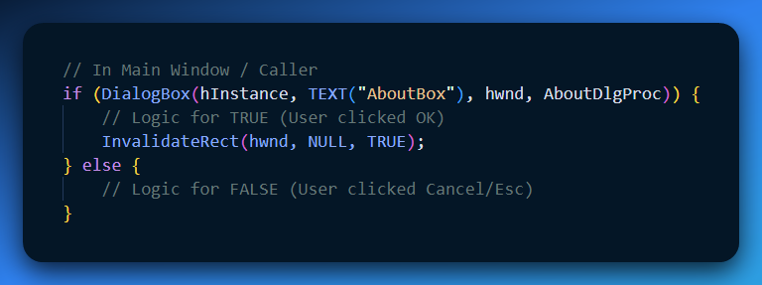

4. Technical Depth: The result Parameter

While TRUE/FALSE is standard, EndDialog(hDlg, int nResult) accepts any int.

* **Use Case**: Passing a specific index, a bitmask of options, or a custom error code back to the parent without using global variables.
* **Memory**: The dialog is not actually destroyed until the DlgProc returns TRUE. EndDialog just sets a flag in the system to close it.

Encapsulation: Passing Structures to DlgProc

To avoid global state (which leads to naming collisions and non-reentrant code), pass a pointer to a custom structure during the dialog initialization.

1. The Data Structure

Define a struct that holds all persistent state required by the dialog.

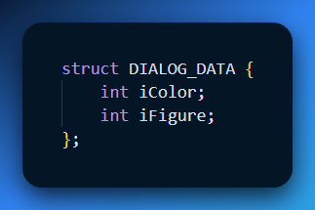

2. Implementation: The Handshake

The transfer happens in two steps: moving data **in** via DialogBoxParam and retrieving it via GWLP_USERDATA.

**Step A: Passing Data In**

Instead of DialogBox(), use DialogBoxParam(). The last argument is a LPARAM (effectively a void*).

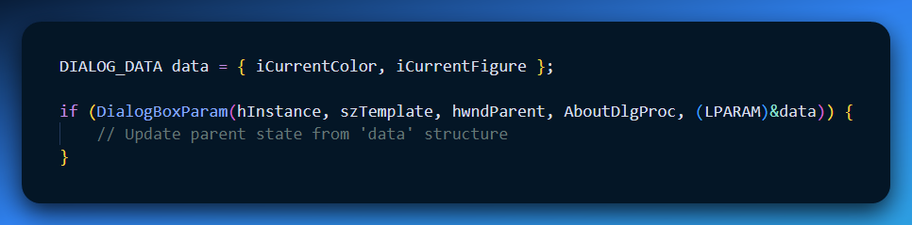

**Step B: Capturing and Storing (WM_INITDIALOG)**

When the dialog initializes, the lParam contains the pointer to your struct. Store it in the window's internal user data to access it later.

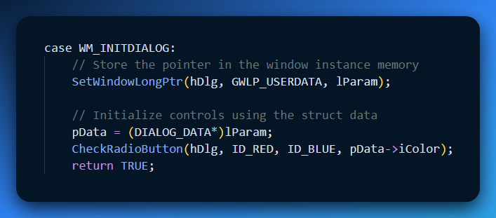

3. Step C: Retrieval during WM_COMMAND

When the user clicks **OK**, retrieve the pointer to update the struct before the dialog closes.

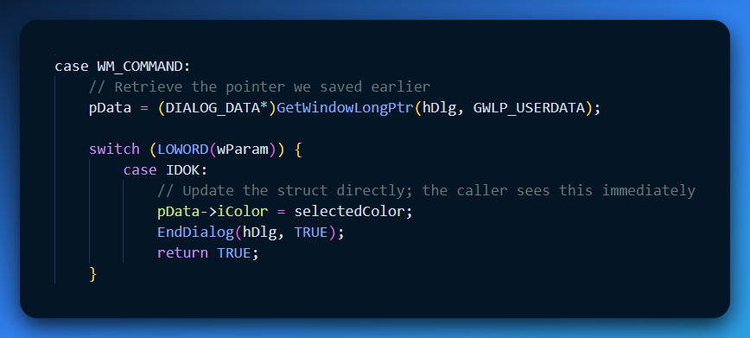

Pattern: The Pointer-Proxy Method

Instead of creating a second static copy of the data inside the DlgProc, we treat the structure pointer as the single source of truth.

1. Caller Side (WndProc)

Use a static struct to persist data across multiple dialog calls. Pass its address via DialogBoxParam.

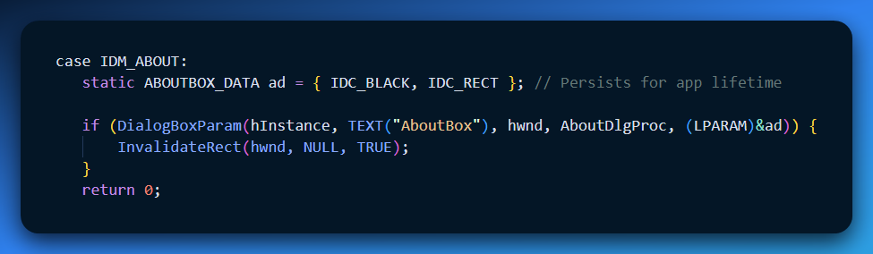

2. Dialog Side (AboutDlgProc)

Eliminate the local static copy. Use the pointer directly to avoid synchronization issues.

* **Extraction (WM_INITDIALOG)**: Grab the pointer from lParam and "pin" it to the window.
* **Access (WM_COMMAND)**: Retrieve the pointer whenever a control is clicked.

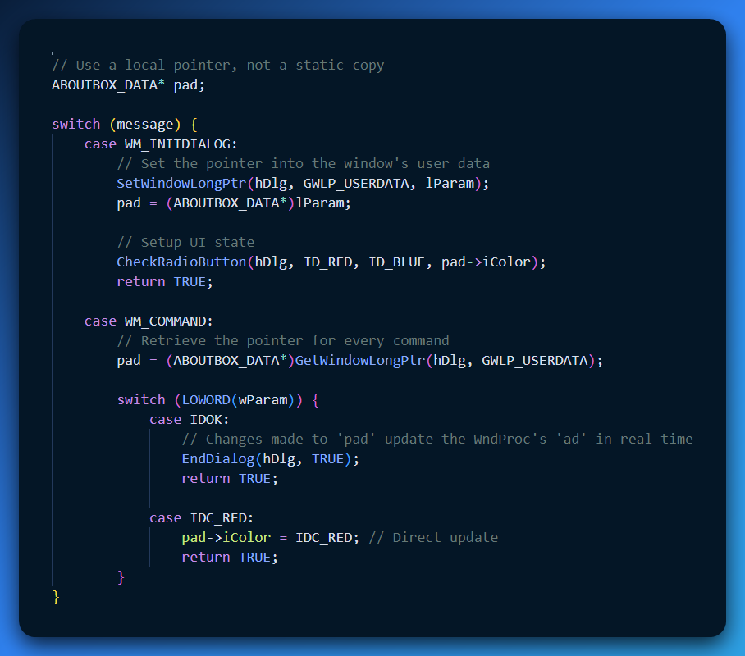

Keyboard Navigation: Tab Stops & Groups

Windows uses two specific window styles to dictate how the "Dialog Manager" intercepts and reroutes keyboard messages.

1. Tab Stops (WS_TABSTOP)

Controls the "Jump" logic (The **Tab** key).

* **Behavior**: Moves focus to the next control in the Z-order that has this style.
* **Initial Focus**: The first control in the resource script with WS_TABSTOP gets focus on startup (unless overridden in WM_INITDIALOG).
* **Dynamic Logic**: For Radio Buttons, Windows automatically moves the WS_TABSTOP style to the **currently selected** button in the group. This ensures that tabbing *into* a group always hits the active choice.

2. Groups (WS_GROUP)

Controls the "Cycle" logic (The **Arrow** keys).

* **Definition**: A group starts at a control with WS_GROUP and ends exactly one control *before* the next WS_GROUP style appears in the script.
* **Navigation**: Arrow keys cycle focus **only** within these boundaries. It is a closed loop.
* **Static Controls**: Labels (LTEXT, etc.) often have WS_GROUP by default to act as "terminators" for the preceding group of controls.

3. Case Study: ABOUT2 Resource Structure

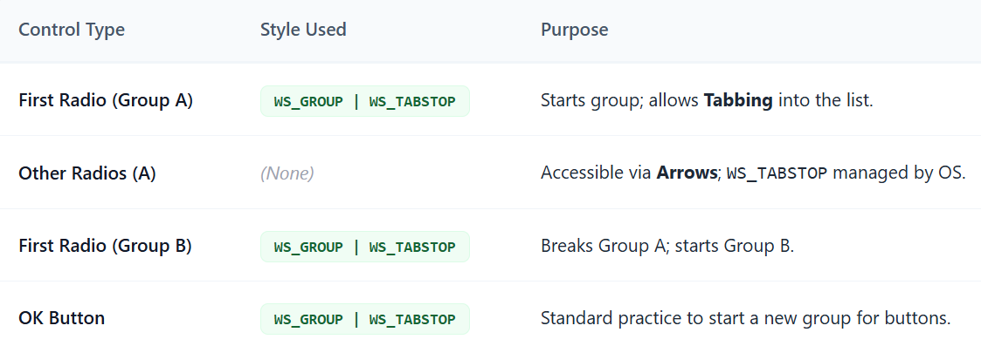

4. Direct API Access

If you need to calculate navigation programmatically (e.g., for custom control behavior), use these:

* **GetNextDlgTabItem(hDlg, hCurrent, bPrev)**: Returns the HWND of the next/previous tab stop.
* **GetNextDlgGroupItem(hDlg, hCurrent, bPrev)**: Returns the next/previous item within the current group boundary.

The Resource Script (.rc) Architecture

The relationship between your .rc file and keyboard behavior is strictly linear. The **Z-order** is determined by the order of appearance in this script.

1. Resource Syntax Breakdown

Don't describe the feature; show the implementation.

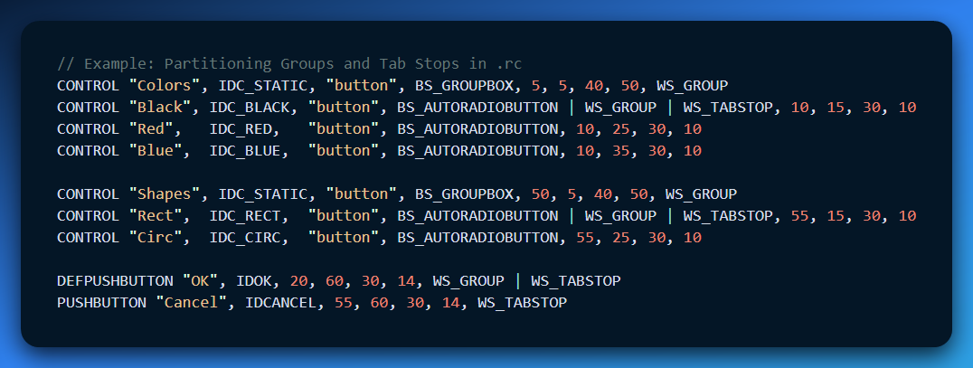

2. The "Implicit" vs "Explicit" Rules

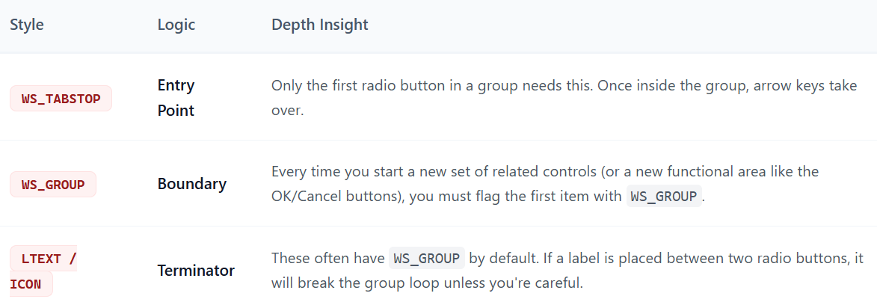

3. Dynamic Style Swapping (Windows "Magic")

You mentioned Windows automatically updating WS_TABSTOP. Here is the technical "Why":

* When you click a Radio Button, the Dialog Manager internally removes WS_TABSTOP from the previously selected button and applies it to the new one.
* **Result**: If you Tab out of the dialog and Tab back in, focus returns to your *selection*, not just the first item in the list.

4. Navigational API Reference

Use these when writing custom controls that need to mimic dialog behavior:

* **hNext = GetNextDlgTabItem(hDlg, hCurrent, FALSE);**
* **hPrevGroup = GetNextDlgGroupItem(hDlg, hCurrent, TRUE);**

The WM_INITDIALOG Focus Contract

The Dialog Manager uses the return value of WM_INITDIALOG as a boolean flag to determine who handles the initial focus.

1. The "Automatic" Focus (Return TRUE)

If you return TRUE, Windows automatically sets the focus to the **first control** in the resource script that has the WS_TABSTOP style.

* **Pro**: Zero code required.
* **Con**: Limited flexibility if you want to start the user on a specific field (like a text box in the middle of the form).

2. The "Manual" Focus (Return FALSE)

If you want a specific control to have focus when the window appears, you must set it manually and tell Windows **not** to override you.

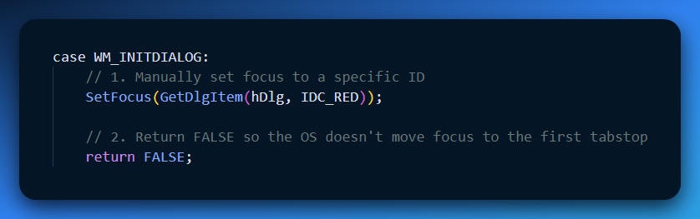

Logic Flow: Handling Selections

Don't just list the IDs; group them by their **behavioral category**. This makes your WM_COMMAND block much easier to read.

1. Grouped Selections (Radio Buttons)

When these are clicked, you are typically updating the internal state (the pad structure we discussed earlier).

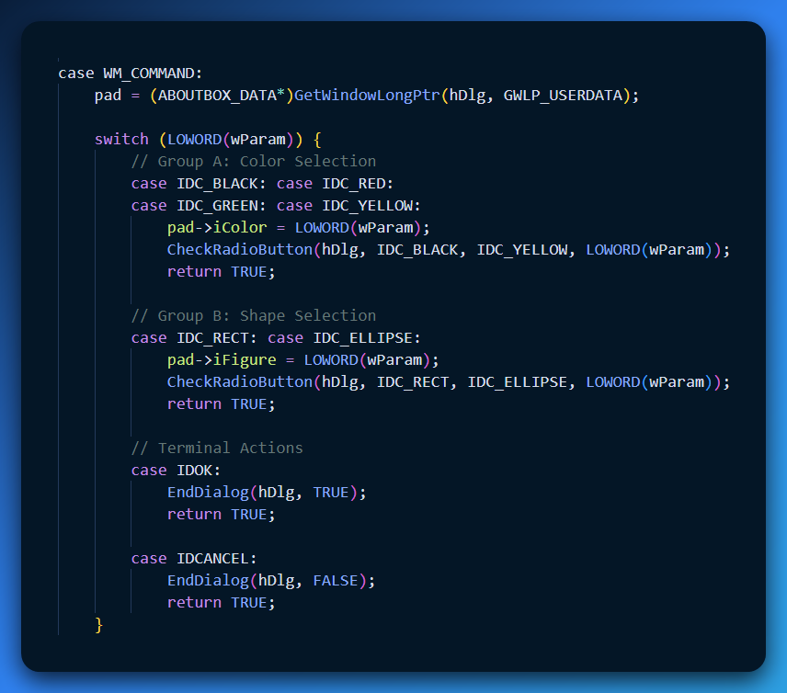

Visualizing the Script-to-Screen Logic

The order in your .rc file creates the "Index" that the Tab key follows.

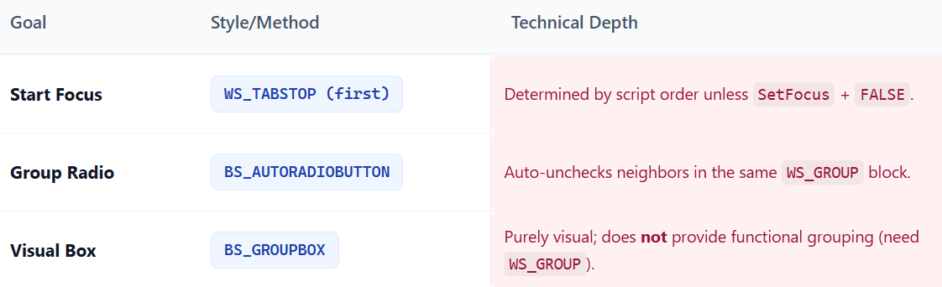

The "Canvas" Trick

In Windows, you can't easily just "draw" on empty space in a dialog because the Dialog Manager controls the layout. **The Hack:** We create a standard control to serve as a placeholder.

* **The Control:** An LTEXT (Static Text) control.
* **The Trick:** We give it **no text** (empty string) and a specific size (e.g., 18 width, 9 height).
* **The Result:** Windows reserves a rectangle of space for us, but draws nothing there. This is our "Canvas."

The Chain Reaction (PaintTheBlock)

When the user clicks a "Color" or "Figure" button, the drawing needs to update. This triggers a specific sequence of functions.

**Step A: InvalidateRect (Wipe the Slate)**

* **Command:** "Hey Windows, this specific rectangle is 'dirty' (outdated)."
* **Result:** Windows erases that area (usually fills it with the background color).

**Step B: UpdateWindow (The Rush Order)**

* **Command:** "Paint it NOW. Don't wait for the next refresh cycle."
* **Result:** This forces an immediate WM_PAINT message to be processed.

**Step C: PaintWindow (The Artist)**

* **Command:** "Draw the new shape."
* **Action:** This custom function executes the actual GDI commands (Rectangle, Ellipse) to draw the new figure in the new color.

Inside the Artist Function (PaintWindow)

This function does the heavy lifting.

1. **Get Permission (GetDC):** It gets a "Handle to Device Context" (HDC) for the child window (the canvas). This is your pass to draw pixels.
2. **Measure the Canvas (GetClientRect):** It asks, "How big is this rectangle in *pixels*?" (e.g., 200x100px).
3. **Pick the Tool (CreateSolidBrush):** It creates a brush based on the user's color choice.
4. **Draw (Rectangle / Ellipse):** It draws the shape using the brush and the size coordinates.

Technical Deep Dive: Dialog Units vs. Pixels

This is a classic headache in Windows programming.

* **Dialog Units (DLU):** In your .RC file, you defined the size as 18 x 9. These are **not** pixels. They are based on the font size. If the user has "Large Fonts" turned on, 18 DLUs gets bigger.
* **Pixels:** Drawing functions (like Rectangle) only understand pixels.

**How to Convert?**

* **Method A (GetClientRect):** Used in this example. It looks at the *actual* window on screen and asks, "How many pixels wide are you right now?" This is the easiest method.
* **Method B (MapDialogRect):** This is a conversion function. It takes your 18 x 9 DLUs and mathematically converts them to pixels (e.g., 18 DLUs = 40 pixels).

Explain Like ur a Teenager: The Reserved Table

Think of the Dialog Box as a crowded **Restaurant**.

1. **The LTEXT Control:** You call the restaurant and reserve "Table 5." You don't sit there yet; you just put a "Reserved" sign on it so nobody else takes that space.
2. **PaintTheBlock:** You decide to decorate the table for a birthday party.
3. **InvalidateRect:** You clear off the old dirty dishes.
4. **PaintWindow:** You bring in the balloons, the cake, and the tablecloth (The Drawing).

*Note:* You only decorate **Table 5**. You don't start throwing confetti on the other tables (The Buttons).

Quick Review

**Question 1:** Why do we use an LTEXT control with no text? *(Answer: To reserve a specific rectangular area in the dialog layout where we can draw later.)*

**Question 2:** What is the difference between InvalidateRect and UpdateWindow? *(Answer: InvalidateRect marks the area as "needs painting" (adds it to the queue). UpdateWindow forces the queue to process immediately.)*

**Question 3:** Why can't we just use the coordinates 18, 9 inside the Rectangle() drawing function? *(Answer: 18, 9 are Dialog Units (relative size). The drawing function requires Pixels (absolute size). We must convert them or measure the window first.)*

Dynamic Control: Changing Things at Runtime

Standard dialogs are static. Advanced dialogs react to what is happening. We use two main functions to make controls "come alive."

A. Moving Controls (MoveWindow)

Usually, buttons stay where you put them in the Resource Script. But you can move them with code.

**Function:** MoveWindow(hwndControl, x, y, width, height, bRepaint)

**Use Case:**

* **Animation:** Make a button slide out of the way.
* **Pranks:** A "Click Me" button that jumps away when you try to click it.
* **Resizing:** Adjusting the layout if the user stretches the window.

B. Enabling/Disabling (EnableWindow)

This is the most common professional technique.

**Function:** EnableWindow(hwndControl, bEnable)

* TRUE: The control works normally.
* FALSE: The control is "Grayed Out" and ignores clicks.

**Use Case:**

* You have a "Next" button in a wizard. You disable it (FALSE) until the user types in their Name. Once they type, you enable it (TRUE).

The Case Study: ABOUT3 (Custom Controls)

The ABOUT3 program is famous for one thing: **Elliptical Buttons**. Standard Windows buttons are rectangles. If you want a circle, a star, or a weird shape, you cannot use the standard BUTTON class. You have to build your own.

How It Works (The 3-Step Process)

**Step 1: Register a Custom Class** Before creating the Dialog, your main program must register a new window class (e.g., "EllipPush").

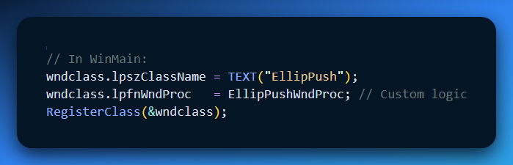

**Step 2: Use It in the Resource Script (.RC)** Instead of writing PUSHBUTTON, you use the generic CONTROL keyword and specify your custom class name.

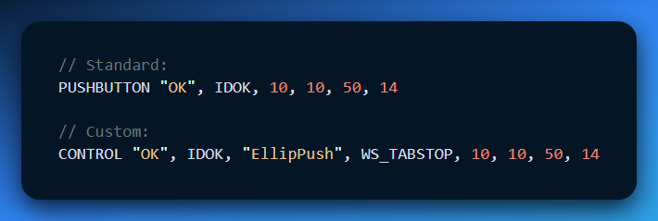

**Step 3: The Custom Logic (EllipPushWndProc)** You have to write the code that draws the button and handles the clicks.

* **WM_PAINT:** You don't just fill a rectangle; you use Ellipse() to draw a round shape.
* **WM_LBUTTONUP:** You detect the click and send a WM_COMMAND message to the parent dialog so it acts like a real button.

Explain Like ur a Teenager: Custom Buttons

Standard Buttons are like IKEA Furniture.

They are easy to use, everyone knows how they work, but they all look exactly the same (Rectangles).

Custom Controls (ABOUT3) are like Building Lego.

**The "CONTROL" keyword:** This is a blank baseplate.

**The Window Class:** You have to build the logic yourself.

* *"When I paint, I want to look like a Circle."*
* *"When clicked, I want to flash red."*

**The Result:** It takes more work, but you can make a button that looks like *anything*—a spaceship, a circle, or a picture of a cat.

Quick Review

**Question 1:** If you want a button to become unclickable because the user hasn't finished a form, which function do you use? *(Answer: EnableWindow(hwndButton, FALSE).)*

**Question 2:** To use a custom "Elliptical Button" in a Dialog, what must you do inside WinMain before creating the dialog? *(Answer: You must RegisterClass the custom window class for the button.)*

**Question 3:** Can MoveWindow change the size of a control, or just its position? *(Answer: It does both! It takes x, y (position) and width, height (size).)*



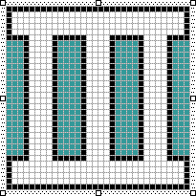 The icon for the program.

The Core Concept: "EllipPush"

Standard buttons (BUTTON class) are always rectangles. ABOUT3 proves that you can build your own button class (e.g., "EllipPush") that looks and acts however you want (in this case, an Ellipse).

To do this, you must take over the responsibilities usually handled by Windows: **Painting** and **Clicking**.

1. The Setup (The 3-Step Recipe)

Creating a custom control isn't magic; it's just a standard Window that lives inside a Dialog.

1. **Register the Class (C Code):** In WinMain, you register a class named "EllipPush". You give it a custom Window Procedure (EllipPushWndProc).
2. **Embed in Dialog (RC Code):** In the Resource Script, you don't use PUSHBUTTON. You use CONTROL and specify the class name "EllipPush".
3. **The Logic (WndProc):** You write the code to draw the circle and handle the mouse clicks.

2. The Custom Window Procedure (EllipPushWndProc)

Since this is a custom window, Windows doesn't know how to draw it. You have to write the code for *everything*.

**A. Visuals (WM_PAINT)**

* **Standard Button:** Windows draws a grey rectangle and text.
* **EllipPush:** You use GDI functions.
  1. GetClientRect: "How big am I?"
  2. Ellipse: "Draw a circle that fits this space."
  3. DrawText: "Center the text inside that circle."

**B. Interaction (WM_LBUTTONUP & WM_KEYUP)**

* **The Problem:** A generic window doesn't know it's a button. Clicking it does nothing.
* **The Fix:** You must manually detect the click (or Spacebar press) and notify the Boss (The Parent Dialog).

**The Code:**

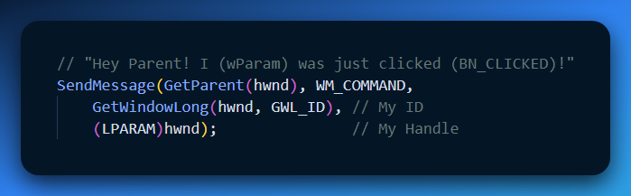

3. Dynamic Behavior (EnableWindow)

The example also reinforces **State Management**.

* **Scenario:** The "OK" button should be disabled until the user acts.
* **Mechanism:** EnableWindow(hwndButton, FALSE).
* **Visual Consequence:** Since you wrote the WM_PAINT code, *you* must also write logic to check IsWindowEnabled(hwnd). If it returns FALSE, you should draw the text in grey; otherwise, draw it in black.

4. Explain Like I'm a Teenager: Frozen vs. Homemade Pizza

**Standard Controls (PUSHBUTTON):** This is a **Frozen Pizza**. It's easy, reliable, and takes zero effort. But you can't change the shape, and it always tastes the same.

**Custom Controls (EllipPush):** This is **Making Pizza from Scratch**.

* You have to make the dough (Register Class).
* You have to shape it yourself (WM_PAINT / Ellipse).
* You have to bake it (Handle Input).
* *The Benefit:* You can make it star-shaped, stuffed-crust, or whatever you want.
* *The Cost:* If you forget to bake it (SendMessage), it's raw and useless.

5. Quick Review

**Question 1:** Why do we need WM_KEYUP handling in a custom button? *(Answer: For accessibility. Users expect to be able to tab to a button and press "Spacebar" to click it. Mouse support alone isn't enough.)*

**Question 2:** In the .RC file, what keyword replaces PUSHBUTTON when using a custom class? *(Answer: CONTROL.)*

**Question 3:** Does the Parent Dialog know that "EllipPush" is a custom control? *(Answer: No. The Parent just receives a standard WM_COMMAND message. It doesn't care if the button is a rectangle or a circle; it just knows it was clicked.)*

The "Pro" Custom Control Checklist

To make a custom window procedure (like EllipPushWndProc) behave like a native Win32 button, you must manage **Input State** and **Persistence**.

1. Visual Feedback (The "Flash")

Native buttons don't just "click"; they toggle state.

* **Trigger**: WM_LBUTTONDOWN or WM_KEYDOWN (Spacebar).
* **Logic**: Set a "Depressed" flag and call InvalidateRect.
* **Depth Insight**: You must also handle WM_KILLFOCUS. If the user TABs away while holding the spacebar, the button must "pop" back up visually.

2. Mouse Capture (SetCapture)

Crucial for UX. If a user clicks your button, holds the mouse, and drags it away, the button should "un-press." If they drag it back in, it should "re-press."

* **Action**: On WM_LBUTTONDOWN, call SetCapture(hwnd).
* **Tracking**: In WM_MOUSEMOVE, check if the cursor is still within GetClientRect.
* **Release**: On WM_LBUTTONUP, call ReleaseCapture().
* **The Command Rule**: Only send WM_COMMAND to the parent if the mouse is **inside** the rect when the button is released.

3. The Enablement State (WM_ENABLE)

Controls aren't just On or Off; they are **Enabled** or **Disabled**.

* **Implementation**: In your WM_PAINT, check IsWindowEnabled(hwnd).
* **Visual**: If FALSE, use GetSysColor(COLOR_GRAYTEXT) for the label instead of the standard button text color.

4. Per-Instance Data (cbWndExtra)

If you have 10 custom buttons, they shouldn't share static variables. They need "Instance Memory."

* **Setup**: In WNDCLASS, set cbWndExtra = sizeof(HANDLE) (or a custom struct size).
* **Usage**: Store a pointer to a state-struct or a simple flag directly in the window's internal memory.

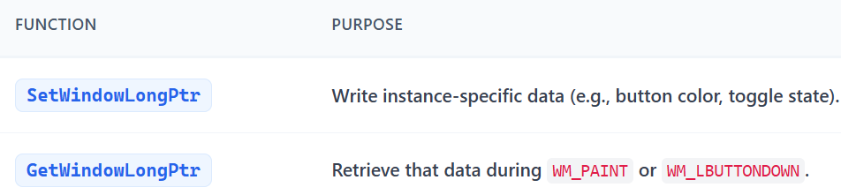

End.